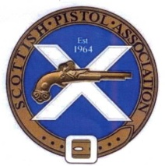Scottish Gallery Rifle and Pistol Championships 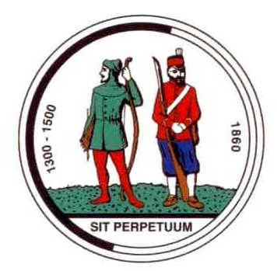

The inaugural Scottish Gallery Rifle and Pistol Championship will be held over two venue dates. Commencing on the 5th July at the JSPC Colmsliehill range where a series of short events will be held and concluding with 1500 events at Drums Links the home of Aberdeen Full Bore Gun Club on the 2nd August. The Championship for Rifle will be held concurrently with a shorter Championship for Long Barrelled Revolver and Pistol. This will be a registered event and entrance open to all.

Scottish Gallery Rifle Champion for Small bore and Centre fire Rifle
Competing for award, Scottish Champion, eight individual title (medal) awarded on the event day.
Scottish Gallery Rifle Champion title awarded to the competitor with the highest overall score from all 8 events, awarded upon championship completing presentation held at the Nationals at Bisley in August.
Venue 1; Joint Services Pistol Club Colmslie hill range 5th July starting at 9.30 am.
Events; TP1, MT and 25mtr Precision.
Venue 2; Aberdeen full Bore Gun Club Drums Links range 2nd August starting at 9.30am.
Events; 1500.
Scottish Long Barrel Revolver and Long Barrel Pistol Championship.
Scottish Champion, competing for four individual title (two LBP and two LBR) medal awards.
Venue; Joint Services Pistol Club Colmsliehill range 5th July starting at 9.30 am.
Events; TP1, MT.
Classifications. This competition is a registered event and scores submitted to the NRA. The Gallery Rifle Ranking Tables will include the 1500 event.
Competitors entering both Standard and Classic matches must indicate to the match director prior to the match commencing which score (standard or classic) they require to be carried forward for their aggregate score. No differential will be made between Iron and Optic (Open class) revolver or pistol. Centre Fire may include any pistol calibre lever action rifle. Lever release rifles are not included due to predicted low entrance, we will look at that again next year
There will be a prize giving ceremony held during the Gallery Rifle Nationals held at Bisley on the Sat 29th of August, venue to be agreed. Two title awards will be made:
- Scottish Gallery Rifle Champion awarded to the highest scoring (rifle) competitor, aggregate score of all eight centre fire and small bore rifle events. No separate classification awards will be made.
- Scottish Gallery Pistol Champion, highest aggregate score of all Pistol and revolver events.

The Scottish Gallery Rifle and Pistol Championships Entry Form.
5th July and 2nd August 2015
Competitor’s details: please print clearly throughout.
Information will be stored on computers for administration purposes.
Name; NRA GRID No. If applicable.
Address;
E mail; Contact Tel No.
Club
Please Tick the events you wish to enter and total up the entrance fee.
Championship Matches, 5th July at Joint Services Pistol Club, Colmsliehill range, near Galashiels.
Event. 25m Precision. 0101 Small Bore ___ 0102 Centre fire __ 0104 Classic ___ ___ entries x £5 = £ ___
Event. TP1. Rifle 0701 Small Bore __ 0702 Centre fire__ 0704 Classic___ ___ entries x £5 = £ ___
Event. TP1. Pistol 0721 Long barrel pistol __ 0722 Long barrel revolver ___ ___ entries x £5 = £ ___
Event. MT Rifle 1101 Small Bore ___ 1102 Centre fire ___ 1104 Classic___ ___ entries x £5 = £ ___
Event. MT Pistol 1121 Long barrel Pistol ___ 1122 Long barrel Revolver __ ___ entries x £5 = £ ___

Championship Matches, 2nd August at AFBGC Drums Links Range Aberdeen.
Event. 1500 Rifle 1501 Small bore___ 1502 Centre Fire___ 1504 Classic___ ___ entries x £8 = £ ___
TOTAL £____
Payment details: - Please make your cheque payable to Scotland Gallery Rifle.
Send entry and payment to: Leslie Kong (SGR), 13 Kevock Road, Lasswade, Midlothian. EH18 1HX
If you are sharing a Rifle please state the other person’s name and grid number.
Note the use of LBR and LBP will only be permitted by competitors with the required FA certificate in place.
Declaration – this must be signed by all competitors
I declare that;
- I am not a prohibited person within the meaning of section 21 Firearms Act 1968 (as amended).
- I hold a firearms certificate permitting me to use the firearms that I shall fire in this competition for target shooting.
- I agree that the results and classifications may be published on the internet or elsewhere (please note that only your name, competition number, class and score will be posted).
- I agree to abide by the rules of the National Rifle Association and of the meeting I will accept the decisions of the Meeting Director or the NRA as final.

SIGNED __________________________________________________________DATED__________________

